Ketua : **Naufal Iksham** (5236354)

Anggota : Muhammad Faithur Adel Patria Akbar (4831812)

Mahez Pradana (4522562)

Fadlan Triana Nugraha (4067611)

Alifio Ibnu Nugroho (4830311)

Kelompok : 4

a). **Deskripsi singkat tentang aplikasi ?  
Sebuah aplikasi sederhana mirip toko online. Produk dan kategori dibuat sendiri untuk menentukan barangnya.**

**b). Stack yang digunakan  
Laravel 9, MySQL, Boostrap, Taillwind**

**c). Cara menjalankan aplikasi**

* + - 1. Buka xampp,lalu nyalakan Apache dan MySQL.  
         Clone the project
      2. Move to project folder
      3. Install composer dependencies
         1. composer install
      4. Install NPM dependencies
         1. npm install
      5. Copy .env
         1. cp .env.example .env
      6. Generate laravel key
         1. php artisan key:generate
      7. Create an empty database and change DB_DATABASE on .env
      8. Migrate database
         1. php artisan migrate
      9. Run seeder
      10. Run project
      11. php artisan serve
      12. Buka di browser [http://127.0.0.1:8000/](http://127.0.0.1:8000/register) (jika belum mempunyai akun).
      13. Lalu jika sudah registrasi nanti akan redirect ke halaman login.
      14. Setelah berhasil login nanti user akan redirect ke halaman utama pada aplikasi.
      15. Setelah masuk ke halaman utama user dapat mendambahkan product dan category.

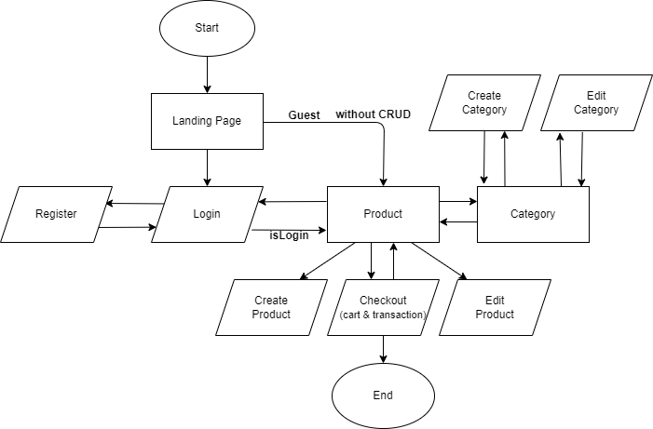**d). Flowchart**

**e). ERD**

**f). Screeshot Aplikasi  
  
Landing Page**

**Login**

**

**Product**

**(belum login)**

**(sudah login)**

**Category**

**Checkout & Transaction**

